**Prompt: Create a Press Release on Luxury Hotel (Pearl Horizon Suites) in Ikeja, Lagos. The launching date will be April 23 2025 with key features and amenities, European Chandelier, quote from the CEO, Proximity to Airport and Landmark sites, with contact information. specify target audience(luxury travelers, families, business professionals) and guests in Hospitality, oil and gas sector, and tech media, there will be weekend deals or packages.**

**PRESS RELEASE**

***FOR IMMEDIATE RELEASE***

***Pearl Horizon Suites Set to Redefine Luxury Hospitality in Ikeja, Lagos***

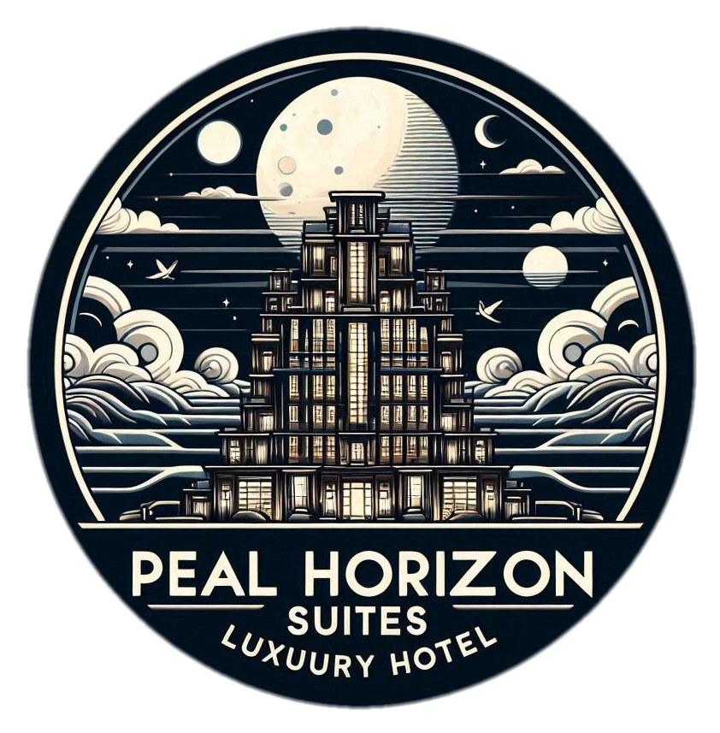

**Grand Opening on April 23, 2025**

**Lagos, Nigeria – [March 1 2025]:** Luxury travelers, families, business professionals, and distinguished guests in the hospitality, oil and gas, and tech sectors are in for a transformative experience as Pearl Horizon Suites opens its doors in Ikeja, Lagos, on April 23, 2025. Strategically located within proximity to Murtala Muhammed International Airport and key landmark sites, Pearl Horizon Suites promises an unparalleled blend of sophistication, convenience, and world-class hospitality.

**A Haven of Luxury and Modern Elegance**

Designed to elevate the standard of luxury accommodations, Pearl Horizon Suites boasts a variety of premium features and amenities:

* **Signature European Chandelier**: A breathtaking centerpiece adorning the grand lobby, setting the tone for elegance from the moment guests arrive.
* **Exquisite Suites**: Spacious, meticulously designed rooms with state-of-the-art furnishings, offering comfort and privacy.
* **Fine Dining**: A selection of gourmet dining options, blending international cuisines with local flavors.
* **Wellness Facilities**: A world-class spa, modern fitness center, and an infinity pool designed for relaxation and rejuvenation.
* **Business and Event Spaces**: Fully equipped meeting rooms and banquet halls catering to corporate events and private celebrations.

**Prime Location with Easy Accessibility**

Pearl Horizon Suites is conveniently located just a 10-minute drive from Murtala Muhammed International Airport, making it an ideal choice for international travelers. Additionally, guests can explore nearby landmark sites such as the Lagos State Secretariat, Ikeja City Mall, and Kalakuta Museum, immersing themselves in the vibrant culture of Lagos.

**Weekend Packages and Exclusive Offers**

To celebrate its grand opening, Pearl Horizon Suites is offering exclusive weekend packages designed to delight every guest. Whether it’s a romantic getaway, a family retreat, or a corporate stay, these tailored deals provide exceptional value and memorable experiences.

**A Word from Our CEO**

“Pearl Horizon Suites is more than a hotel; it’s a destination that embodies the spirit of modern luxury and personalized hospitality,” said Rex Nijhof, CEO of Pearl Horizon Suites. “Our mission is to create unforgettable moments for our guests while setting a new standard for excellence in Lagos. We’re excited to welcome travelers from around the world to experience the beauty, culture, and warmth that Lagos has to offer.”

**Contact Information**

For reservations or inquiries, please contact:  
Kareem Sule  
Front Office Manager  
Phone: +234 8097483902  
Email: kareemsule@pearlhorizonsuites.com  
Website: www.pearlhorizonsuites.com

**About Pearl Horizon Suites**

Pearl Horizon Suites is a premier luxury hotel committed to redefining hospitality with a perfect fusion of elegance, innovation, and exceptional service. Located in Ikeja, Lagos, it caters to discerning travelers seeking unparalleled comfort and convenience.